# 4 Design Sound Effects For Musicians Senior Design Team 37

## 4.1 Design Content

1. A mathematical model for:

a. Peaking Distortion

b. Harmonics of Incoming Signals

c. Filament Temperature Fluctuations

2. Digital Synthesis for:

a. Peaking Distortion

b. Harmonics Introduction

c. Filament Temperature Simulation

3. Integration for Analog inputs/outputs

a. Analog Amplification following DAC on output

b. Analog input/output ports

### 4.2 Design Complexity

1. The design consists of multiple components/subsystems that each utilize distinct scientific, mathematical, or engineering principles
2. The problem scope contains multiple challenging requirements that match or exceed current solutions or industry standards.
3. Gathering the applicable data for developing a the mathematical model necessitates the use of a variety of equipment:
   1. A low-power vacuum-tube amplifier
   2. Digital Multimeter
   3. Digital Oscilloscope
   4. Function Generator
   5. Focusrite Scarlett 2i2
   6. laptop with recording software (audacity) and MATLAB

This equipment is necessary as it allows us to record audio at a high quality directly from the source, which would either be a computer in the case of music tests, or from the function generator for harmonic analysis. Using these materials, we can record audio which has passed through the vacuum-tube amplifier under a variety of conditions. Then, we can use programs such as MATLAB to parse the data from those stored audio files, and conduct any analysis we need to draw an accurate mathematical model for the functional distortion introduced between the original audio signal and the tube-amplifier signal.

### 4.3 Modern Engineering Tools

Oscilloscope - Testing

STM32 Microcontroller - Digital Audio Processing

ADC - Analog to digital converter

DAC - Digital to analog converter

Vacuum Tube(s) - Distortion model

## 4.4 Design Context

| **Area** | **Description** | **Examples** |
| --- | --- | --- |
| Public health, safety, and welfare | Our project is not related to public health, safety, or welfare. | N/A |
| Global, cultural, and social | Our product has the potential to bring the love of Vacuum tube amplifiers to the broader public. | Price is a major barrier to entry for many. The price difference of our design can change that. |
| Environmental | Our project is not environmentally related. | N/A |
| Economic | The price of vacuum tubes is generally a barrier of entry. | The masses may now afford a “super tube amp” |

### 4.5 Prior Work/Solutions

We have found products online which claim to digitally emulate the sound of a vacuum tube amplifier. They have all been VST’s (Virtual Studio Technology) which runs on a computer and is not a physical product. Our product is different as we plan to use it as a physical amplifier.

## Design Decisions

Vacuum tube(s) - Allow for the modeling of distortion.

STM32 - Allows for digital audio processing.

Midi - Allows for manipulation of signal in different ways.

In this project we are still deciding what form of emulation we are trying to emulate. The current methods that we are thinking of doing to emulate a tube amp are create and emulate a tube amp in spice and run it off a microcontroller, use machine learning on the input and output to replicate a tube amp on a microcontroller, or test a real life tube amp and try and recreate its effects on a microcontroller.

## Proposed Design

So far, we have conducted a lot of research on tube amplifiers and the distortion they produce. We have ordered a small tube amp kit and have begun testing the tubes. Additionally, we have begun experiments in digital audio processing and started exploring libraries and microcontrollers that will enable us to manipulate audio and interface with MIDI.

### 4.7.1 Design 0 (Initial Design)

### Design Visual and Description

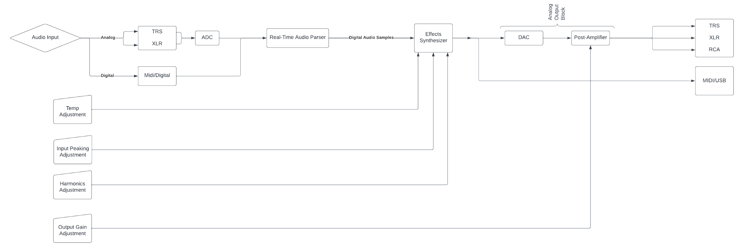

*Figure 1: High-Level System Flowchart (Signal moving Left to Right)*

The Audio signal begins at the “Audio Input” block of the above flowchart. The other four input blocks represent the settings which are adjustable by the user. “Temp Adjustment” is the setting that will adjust the severity of the “Temperature Simulation” circuit, visible in Figure 3. Next, the” Input Peaking Adjustment” control will adjust the level of the input audio which dictates the distortion caused by the “Peaking Distortion” circuit visible in Figure 3. Then, the “Harmonics Adjustment” control will change the severity of the harmonic distortion through the “Harmonics Feedback” circuit visible in Figure 3. The last adjustable input is the “Output Gain Adjustment”, which does not enter the “Effects Synthesizer” as the other three Parameter Controllers do, instead, this just adjusts the gain of the analog audio output (i.e. the volume of the amplifier).

Following the Audio Input and the Parameter Controllers, the audio signal is, if not already, converted to digital. This then gets sent into the Audio Parser, which turns the real time signal into an audio sample for the effects to be added to.

Following the Audio Parser, the parsed audio sample enters the Effects Synthesizer, where one of the three main effects, as shown in Figure 2, are conducted in parallel, to be added together at the end of the Effects Synthesis Circuit.

Once the effects are added, and recomposed into the final output signal, that signal is then sent to the Output Block, which can either consist of sending the signal out over digital protocols (MIDI/USB) or the audio can pass through the DAC to be converted to Analog audio, then through the adjustable amplifier for analog output.

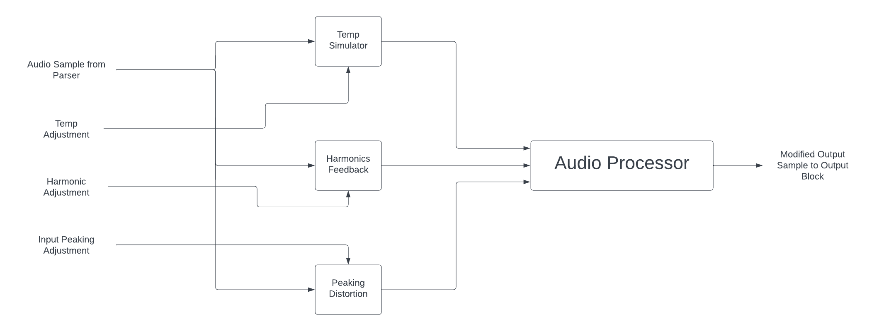

*Figure 2: High-Level design of Effects Synthesizer (visible in Figure 1)*

Within the Effects Synthesizer (Whose Block is shown in FIgure 1), the Digital Audio Sample will be moved in parallel through the three main effects. First, the Temperature Simulator, which will attenuate and distort the signal based on the Temp Adjustment input from the user, the input for which is visible in Figure 1. The Harmonics Feedback circuit will add harmonics and increase Total Harmonic Distortion based on the Harmonic Adjustment Input. The circuit for this module can be seen in Figure 3. The Peaking Distortion circuit will add distortion based on the gain added to the original input signal. This level should only affect the Peaking Distortion, as the Harmonics and Temperature simulations are also related to input levels, which should remain constant for predictable outcomes and keeping the parameters generally independent.

Once the signal has been sent through the three effects circuits, the signals will be recombined in the Audio Processor, which adds the three signals together and sends them to the Output Block.

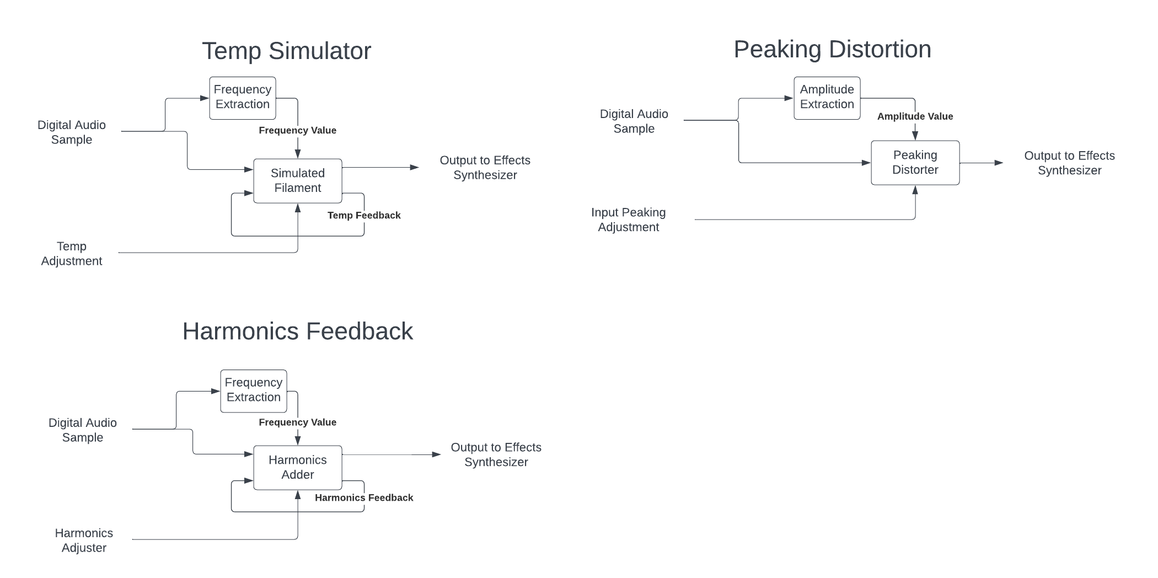

*Figure 3: Design for the three different modules within the Effects Synthesizer*

The three Effects, as shown in the design above, all follow a similar feedback model. For the Temperature Circuit, The Digital Audio Sample will first have its frequency extracted, which will be input as a parameter into the simulated filament. The amplitude of this specific sample will also be read in as a parameter, though no extractor circuit is necessary. Following the circuit’s extraction of a temperature, the sample will be sent out with the proper distortion added, but that current “Temperature” reading will be stored and used to affect the next sample. The “Temp Adjust” input available to the user will cause the simulated filament to heat up more, or cool down faster to amplify or attenuate the effect of the Simulated Filament on the final signal.

In the Peaking Distortion Circuit, an initial amplitude for the input signal is read in, this is treated as a ‘nominal’ value for the amplitude, where no distortion will be applied. Then, the user adjustable Input Peaking Adjustment will move the amplitude of the input sample up or down the curve of the Peaking Distortion circuit to simulate an overloaded audio signal entering the amplifier. This will cause the peaking to become more severe and audible to the listener.

In the Harmonics Feedback circuit, just as in the Temperature Circuit, the frequency is extracted in order to place the harmonics and subharmonics in their proper place at integer multiples of the center frequency (extracted frequency of the audio sample). The severity of the Harmonics, usually decided by the Temperature of the filament, will instead be adjusted by the user in order to allow for the greatest acoustic customizability for the user.

### Functionality

The purpose of our design is to emulate the distortion characteristics of a vacuum tube amplifier. Many people claim to like the sound of these amplifiers more than the modern transistor based amplifiers. Our intended use case of our design is to provide a cheaper alternative to the expensive vacuum tube amplifiers, and deliver the sound which their finatics claim to love so much.

### 4.7.2 Design 1 (Design Iteration)

One change we are thinking of making is the switch from an arduino to an STM32 microcontroller. We have listed this above but are not sure about which we will use yet. We have found libraries to use with the arduino, but the STM32 has a built in DAC. We are currently in the process of deciding which to move forward with.

## **NOTE: The following sections will be included in your final design document but do not need to be completed for the current assignment. They are included for your reference. If you have ideas for these sections, they can also be discussed with your TA and/or faculty adviser.**

## 4.8 Technology Considerations

Highlight the strengths, weakness, and trade‐offs made in technology available.

Discuss possible solutions and design alternatives

## 4.9 Design Analysis

–  Did your proposed design from 4.7 work? Why or why not?

–  What are your observations, thoughts, and ideas to modify or iterate further over the design?